Reception Transport topic ideas (I will continue to share the daily maths and literacy activities. Also the White Rose maths, RWInc websites and Bitesize are doing daily lessons still).
Role play – can you make your own car /bus / aeroplane, using chairs or similar and act out being on it with your family? | Design your own transport ticket. What does it need to include? Price, destination, date etc | Make a vehicle from junk modelling.  Or make a model from any construction toys you may have. | Make a boat to sail  Floating / sinking. Can you find some objects that float?
Make a paper aeroplane – how far does it go? May be each member of your family could design and make one, which goes further? Have a competition.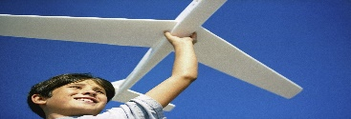 | Draw a map of route to school 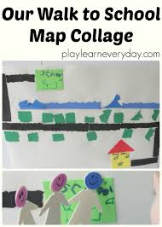 | 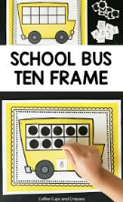  Using tens frames linked to different modes of transport for counting. | Sing the wheels on the bus or choose another song. Here are some ideas.  https://www.bigeyedowl.co.uk/show_songs.php?t=6  Share some stories -- -Whatever Next! Mr Gumpy’s Outing, Mr Gumpy’s Motor car. Mrs Armitage on wheels, Naughty Bus. The Train Ride. Oi!Get Off Our Train.
Photos of transport  Can you take your own photos using a phone / camera / tablet? | Memory game – can you put some vehicles / pictures of vehicles down. Hide your eyes, if someone takes one away, do you know which one is missing? | Draw own road with chalk outside. | Make a non-fiction book about transport. Either choose one type of transport and write lots of information, or choose a few different types with only one or two facts.
Sort vehicles – wheels / no wheels | Paint or draw any type of transport. | Can you make a Paper Mache Hot Air Balloon or one out of paper? | 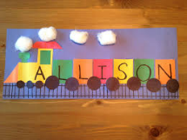  Make a train or a rocket with your name on. Can you spell your surname too?

