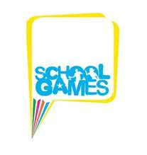
Cramlington and Seaton Valley
School Sport Partnership

Year 3 and 4 Tri Golf Competition.
Whytrig Middle School. Friday 25th April 2014.

We had a great entry in this years’ Tri-Golf competition and nine teams from across the partnership took part in eight games designed to test their skill in putting and chipping.

The final scores were very close with only around Forty points between the top three teams. Congratulations to Shanklea Primary School on their victory.

The standard of Golf continually improved as the morning progressed and all pupils displayed the all of the School Games values, particularly exceptional team work. Well done to all the teams for their effort and excellent behaviour

The winning team, Shanklea Primary School, will go on to represent Cramlington Seaton Valley School Sport Partnership at the Northumberland School Games in June, where they will play against teams from schools across Northumberland.

Many thanks to the leaders from Whytrig Middle School for running the games at the event.

Results:

Position | School | Points Total
1 | Shanklea Primary School | 960
2 | Seaton Delaval First School 1 | 941
3 | New Hartley First School | 915
4 | Beaconhill Primary School 1 | 835
5 | Seaton Delaval 2 | 706
6 | Seaton Sluice First School | 698
7 | Holywell Village First School | 629
8 | Eastlea Primary School | 604
9 | Beaconhill Primary School 2 | 490

