
Eastlea Primary has achieved the School Games Silver Kitemark

Eastlea Primary in Cramlington has recently been awarded the silver kitemark for School Games. This is a great achievement for the school and the kitemark pennant was presented to the children at an assembly on Tuesday by Marie-Anne Dowson (School Games Organiser). Marie-Anne said “It's fantastic that Eastlea have achieved the Silver kitemark – they are the only school in our area and one of few in the County to have done so! I was very happy to come and present their award.”
Last year Eastlea pupils took part in just about every sporting opportunity which became available for the school games events in Northumberland. There were events at local level in a wide range of sports such as tag rugby, football, netball, athletics, gymnastics, tri-golf and tennis.
“Although we are a small school, we like to provide our pupils with as many opportunities as possible – and this includes sporting occasions. Every team that went out to represent Eastlea had a fabulous time and really enjoyed the experience. Three teams won and made it through to the school games finals held in Berwick and Hexham – and our Year 3 Gymnastics, Year 5/6 netball and Year 4 tennis teams represented Cramlington and Seaton Valley superbly in their respective events. We were delighted to have our achievements recognised with the silver kitemark and will be working to regain this award in future years.”
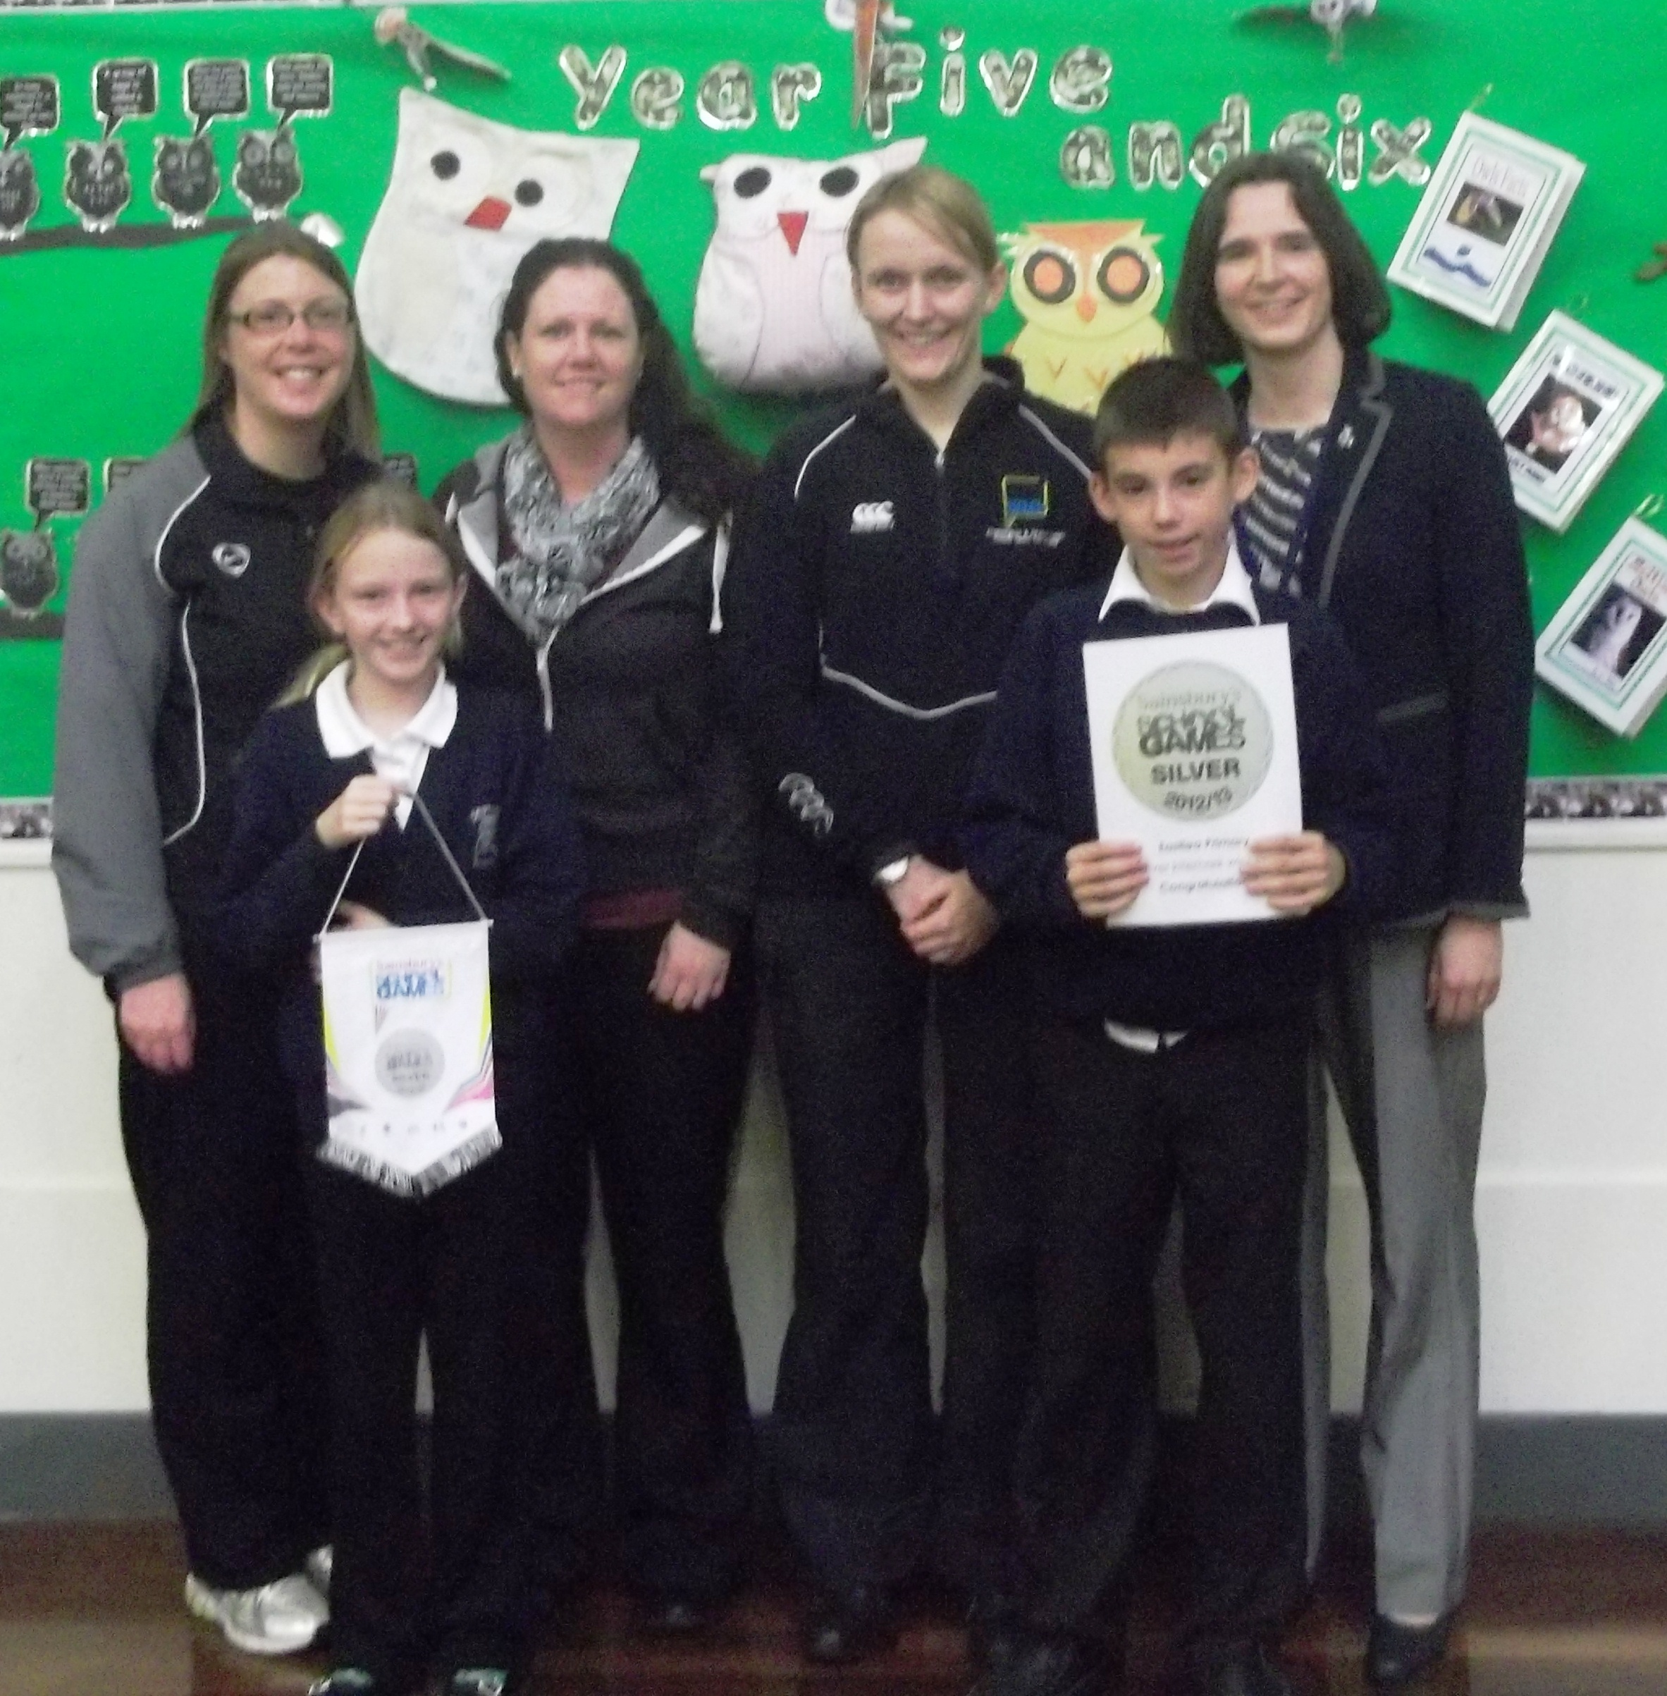
Gill Marsden the Cramlington School Sport Partnership Organiser who also attended the presentation event was very pleased with Eastlea’s achievement. She said “I continue to be inspired by what is going on in Eastlea Primary school, and am delighted that they are getting the silver kitemark to recognise their achievements!”

