Nursery Transport topic ideas. I will also share a daily activity or challenge and remember to keep practising Read Write Inc. sounds and rhymes as well as lots of number and counting activities.
Role play – can you make your own car /bus / aeroplane, using chairs or similar and act out…. | 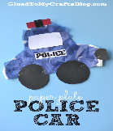  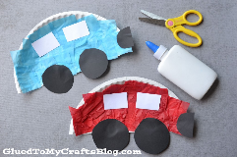  Paper plate cars | Make a vehicle from junk modelling.  Or make a model from any construction toys you may have. | Read stories about transport.  See pictures below.
Paper aeroplane – which goes further?  Make a boat to sail. | 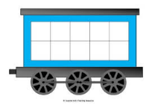  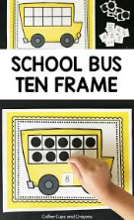  Using tens frames linked to different modes of transport for counting. | 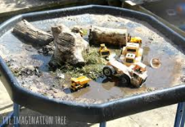  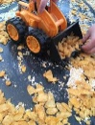  Set up a digger’s/ transport sensory tray. You can use sand, soil, twigs, wood, gravel or even cereal! | 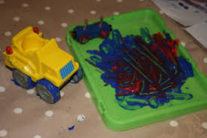  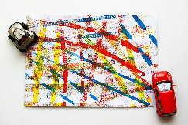  Tyre track crafts
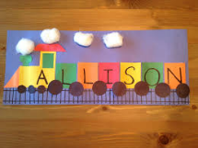  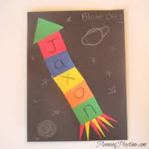  Make a train or a rocket with the child’s name on. | Paint / draw transport | Build a bridge using boxes/lego etc. | Floating and sinking experiments
Sort vehicles – wheels / no wheels. Land/sea air/road etc. | Maths problems involving different modes of transport. | Make a Hot Air Balloon –made from balloon shaped pieces of card and add a basket. | 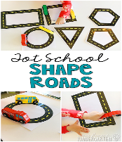  Shape roads
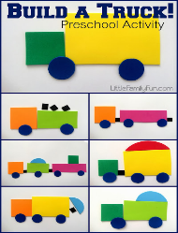  Build a truck | Counting cars using a ‘tens frame’ car park.  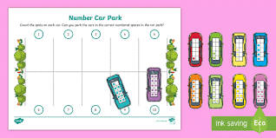 | 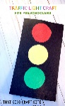  Make a set of traffic lights  Can also play the traffic light game – Hold up a green circle for ‘Go’ a red circle for ‘stop’. | 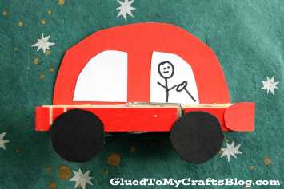  Peg cars

Transport books
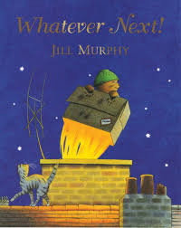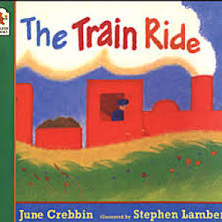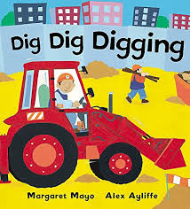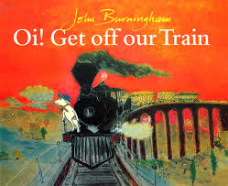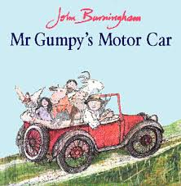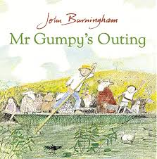
Transport songs
Wheels on the bus , Row Row Row your boat, The Big Ship Sails, A sailor went to Sea Sea Sea, Bobby Shaftoe, Five little Men in a Flying Saucer,
Super simple Songs– lots of transport songs and rhymes https://www.youtube.com/watch?v=zk5HGN8JXXk
Grace’s Amazing Machines on CBEEBIES – lots of different transport themes.

