Nursery home learning activities linked to ‘Down on the farm’. Please feel free to do as many or as few as you would like. Remember to upload photos to Tapestry.
Practise writing name and letter formation.  Writing name. | Stay Active – Just dance kids / Cosmic Kids / Joe Wicks on You Tube | Share at least one story a day. | RWI Sounds and Rhymes daily  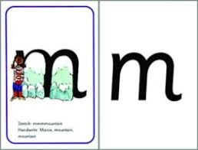 | Recognising numbers to 10  1 more/1 less to 10  Ordering numbers to 10
Hide root vegetables in a tray filled with earth/in sand pit outside – provide spades and buckets for digging them out | Set up a farm shop. Make price lists. Buy from the shop using real coins. | Make a model farm animal /tractor etc. | .Paint a farm animal.  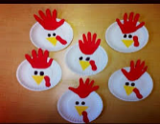  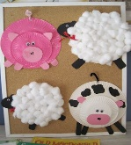  Make a paper plate sheep/pig/hen | Blind folded fruit / vegetable tasting. Can they guess the fruit and describe them?
Grow your own vegetables…..may be a bit tricky unless you have seeds in already! Cress is easy! | Hand print a cow!  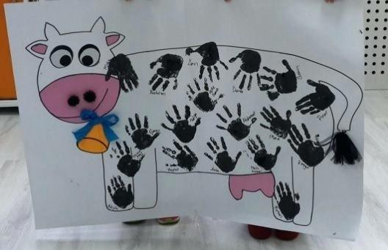 | Play Pictionary with farm animals. | Milk a cow!  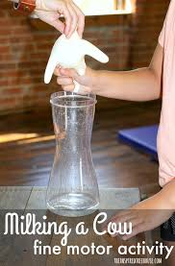 | Make a list of words that rhyme with cat / pig/ dog.  Play I Spy
Make animal biscuits | SORT farm animals eg cows/not cows; hens/not hens, Develop by sorting animals that have four legs/two legs; animals that go into water/do not go into water; have feathers/do not have feathers/ etc. | Number rhymes  Nursery rhymes  and songs such as Old Macdonald. | 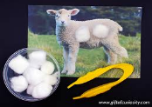  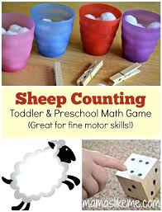  Count cotton wool balls onto a sheep picture | 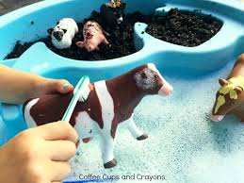  Wash toy animals
Share the story of The Little Red Hen and retell it.  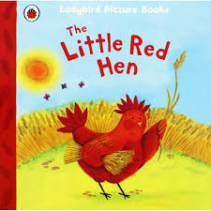 | Share the story of The Enormous Turnip and retell it.  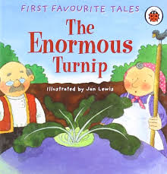 | Find out the names of some baby animals. | Put toy animals on model farm - count them.  Put toy animals in fields - ask children to find the field with three sheep or four pigs. | Use different milk containers in water play and discuss capacity - emphasise comparative vocabulary - biggest, smallest, tallest, shortest etc
Useful websites
Super simple songs - https://www.youtube.com/user/SuperSimpleSongs lots of good action songs which the children already know and love!
Mr Tumble Nursery Rhymes - CBEEBIES another popular one with the children
Alpahblocks and Numberblocks – cbeebies Really good for Phonics and Number recognition
Cbeebies Down on the Farm - https://www.bbc.co.uk/cbeebies/shows/down-on-the-farm different programmes about the farm
Topmarks early years maths – good website with counting activities
Interactive Tens frame - https://www.nctm.org/Classroom-Resources/Illuminations/Interactives/Ten-Frame/ useful counting actvity

