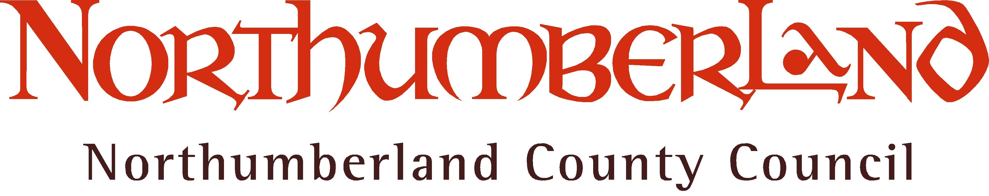
 | Your Ref:  Our Ref:  Enquiries to: Direct Line:  E-mail:  Date: | SEND Survey  E&S/CB/JP  Claire Brown  01670 624049  Claire.brown@northumberland.gov.uk  12 April 2016

Dear Parent/Carer,

Help us to improve the provision for children and young people with Special Educational Needs and Disabilities in Northumberland

We have a duty to listen to you, the parent/carer of a child or young person with special educational needs/disabilities. We want you to tell us what is working well and what could be better for your child in Northumberland.

We would be grateful for 10 minutes of your time to complete an anonymised survey which will help us to identify what we do well and what needs to be improved.

The survey can be found at: http://tinyurl.com/SENDsurvey

The survey will be open from Tuesday 12th April to Wednesday 20th April 2016. The anonymous results will be collated and analysed and will help us to plan for the future.

Thank you in anticipation of your contribution.

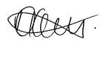

Daljit Lally

Deputy Chief Executive
Executive Director of Wellbeing and Community Health Services

